**Application of Occlusion Culling in Graphics Rendering**

**Tianshi Xie**

**Computer Science, Troy University**

**Troy, United States**

**txie@troy.edu**

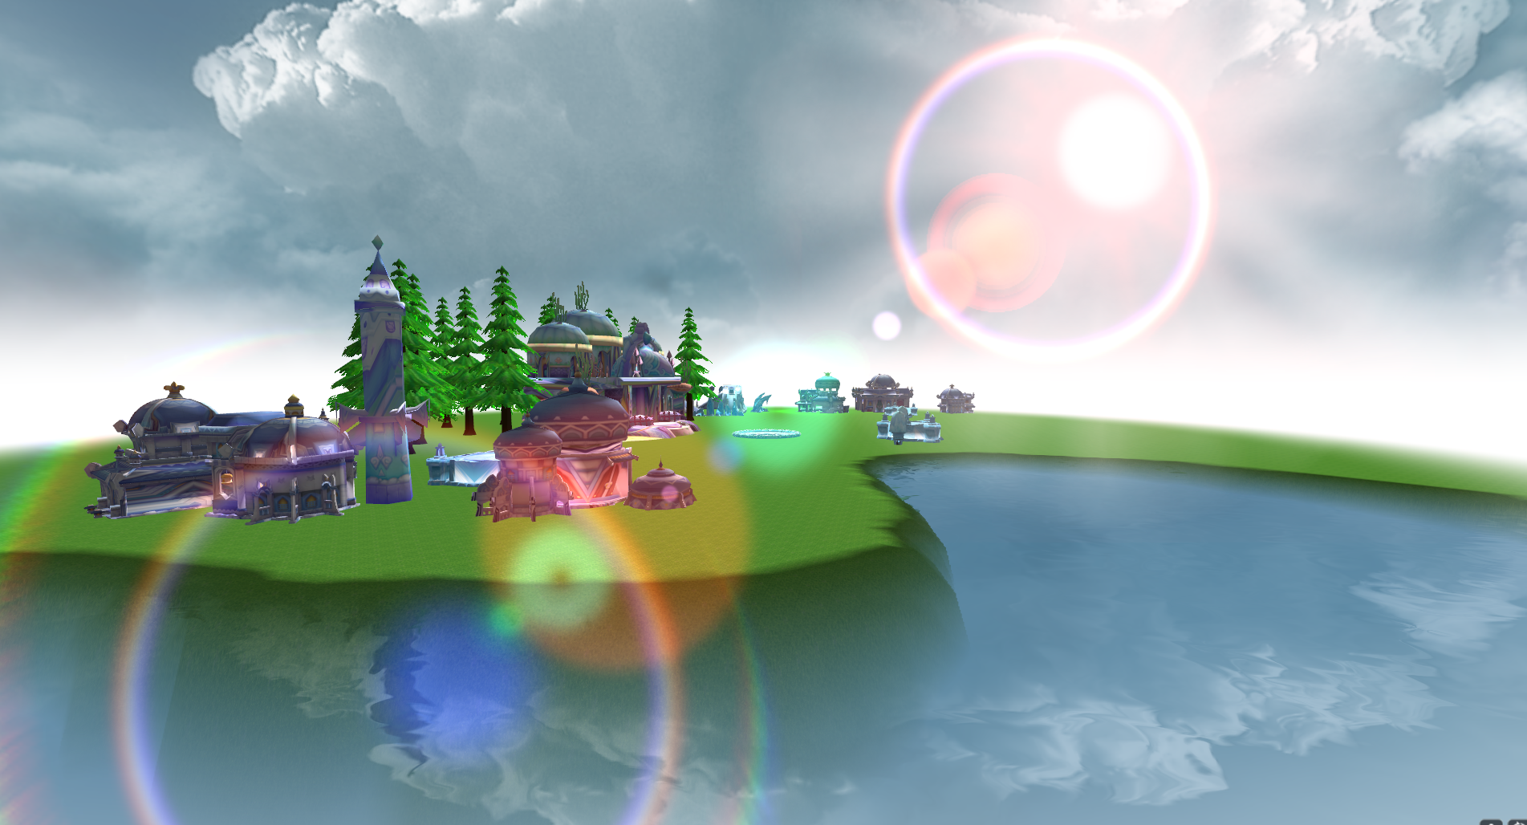

Figure 1

***Abstract***— This paper will present a technology how to increase rendering performance [4] when the geometry is not in the camera’s view or hidden by other objects, which is called occlusion query or occlusion culling. Our goal is to utilize this technology to make a lens flare effect in a Demo which is using OpenGL. In the demo, you should be able to see the lens flare effect and when the Sun goes behind a tree or a house that lens flare effect should not be visible. In addition to that, I am going to illustrate the classic approach which can speed up the performance for GPU and CPU.

***Keywords***—Occluders, Occludees, Depth Buffer,

Frustum Culling, Draw Call.

* Occluders: Objects that are big enough to hide or occlude other objects in the scene.
* Occludees: Objects that are hidden or occluded by other objects in the scene.
* Draw Call [3]: how many objects are being drawn each frame on the screen.
* Depth Buffer: it also called Z-buffer that is used to store the image depth coordinates (z coordinate) in 3D graphics.
* Frustum Culling: Only rendering the object in the camera’s view.

# **Introduction and Related Work**

Occlusion Culling [2]is not same as Frustum Culling [1]. The renderers will not work for objects which are not inside the camera’s area when enable the Frustum Culling but the objects which are occluded by occludes. However, we can still use Frustum culling when using Occlusion Culling.

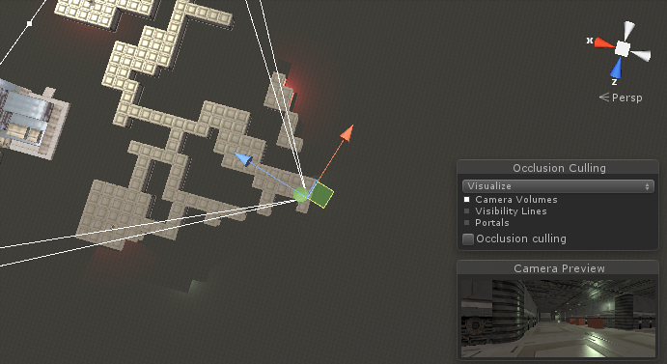

Figure 2

Here is using the frustum culling. You can see that only renders objects which are in the camera’s area.

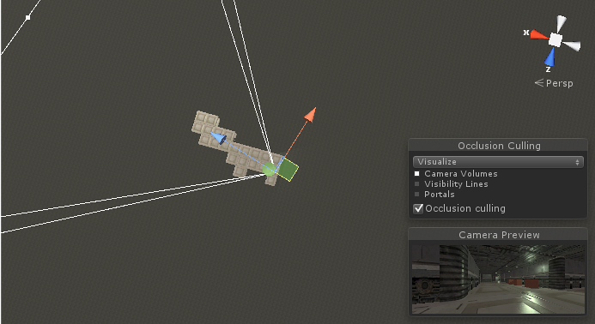

Figure 3

And we also can use the Occlusion culling at the same time. You can see a lot of objects are removed because they are obscured by other objects. They can work together very well.

***Background***

The process of occlusion query will go through the whole scene by using a virtual camera to build visible sets of objects. The data is used to detect whether the object is visible or not. The graphic engine only renders visible objects. This not only reduces the times of draw calls and increases the rendering performance of the game.

You also can see the performance information such as how many triangles, verts, and draw call in the current frame.

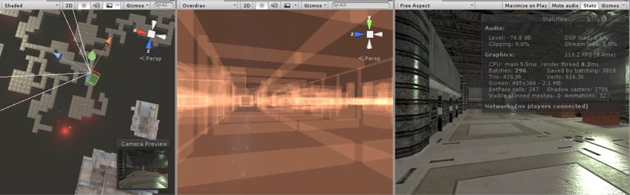

Figure 4

A lot of rooms are rendered beyond the wall.

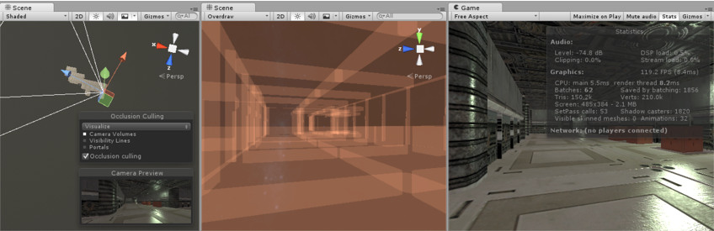

Figure 5

After using occlusion query, the hidden room are not rendered and the number of the triangles from 428.9k to 150.2k and the number of the vertex from 616.3k to 210.0k.

# **How does Occlusion Query work**

## **Theory**

An occlusion query is not difficult. To send the command from CPU to GPU. And GPU decide how many pixels should be visible on screen. These pixels successfully go through all kinds of tests in the pipeline such as the alpha test, the depth test [5] and so on. The process are as follows:

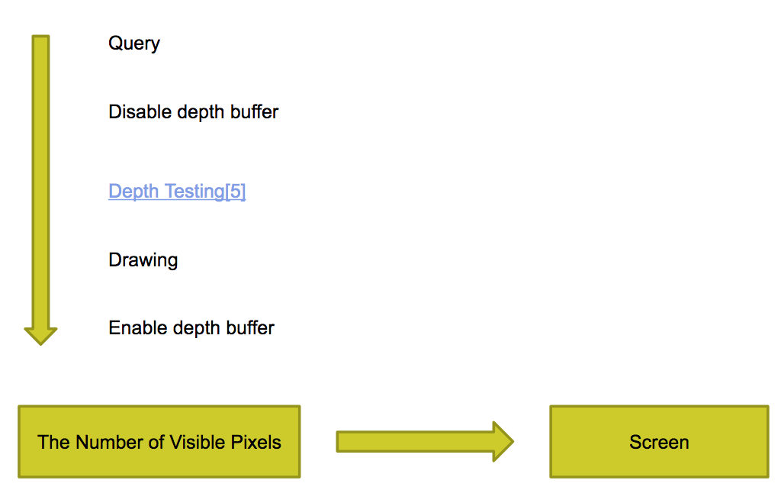

Figure 6

First, we will create a query, then Disable the depth buffer. Only do the depth testing for the object’s bounding box for counting visible pixels. Then enable depth buffer and get the number of available pixels. If the number of visible pixels is greater than 0, render the object to screen. Here we replace an object with a bounding box which determine whether we need to render the object itself. If the object’s bounding box occluded by other objects, we can avoid the object.

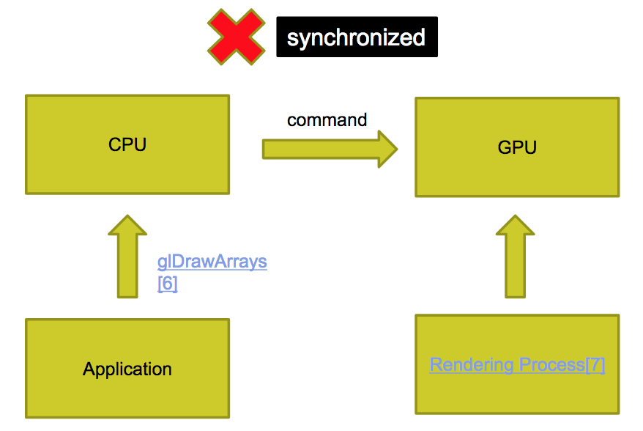

Figure 7

All seems pretty simple but there is one slight complication that we need to consider and that is that our application running on the CPU and the rendering process [7] is going on the GPU are not synchronized this means that when our application reaches a rendering call such as glDrawArrays [6] it doesn’t wait for the GPU to carry out and finish this commands before moving on our application will simply send that command to the GPU and continue straightaway.

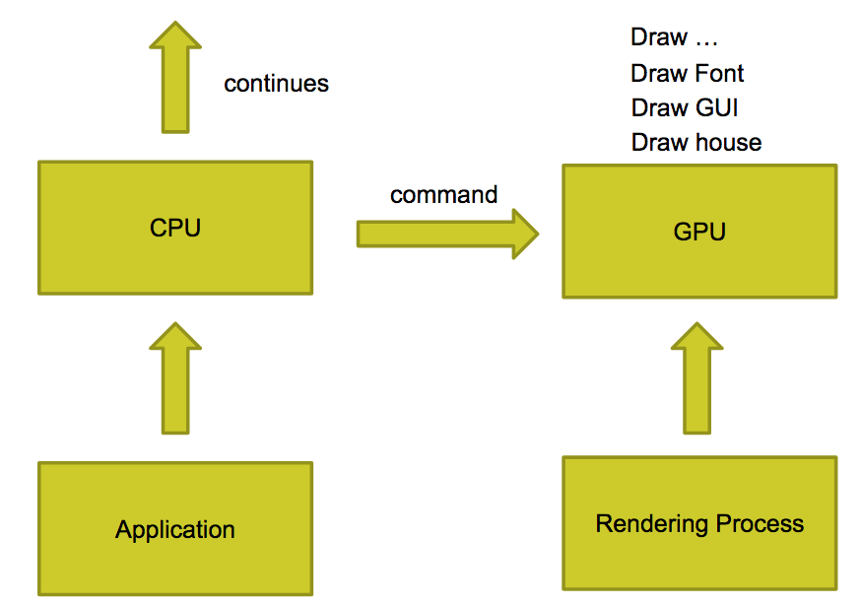

Figure 8

if it comes across more draw calls so that’s the draw calls. look at the Figure 7, the OpenGL [8] function glDrawArrays is a single Draw call that means the software directly notice the video card to render the basic graph that is the vertex to the screen on hardware level. This is of course a very cost and expensive operation. we usually minimize the times of Draw Call to improve the rendering performance. it will do the same thing it simply sends the command to the GPU and continues.

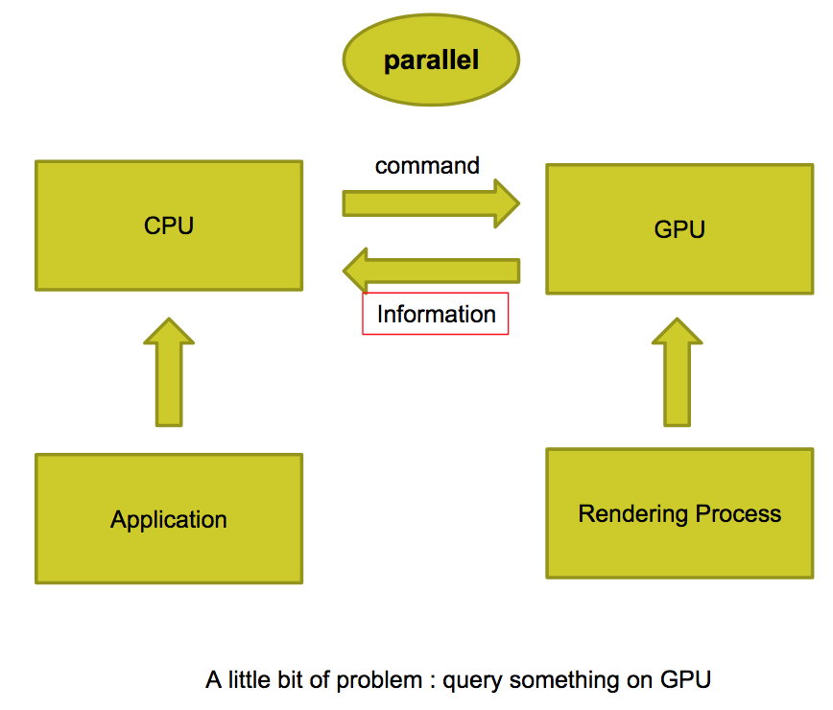

Figure 9

The GPU then queues up these commands as it receives them and carries them out in its own time this is very good for performance because it means that the CPU and GPU can work in parallel and the GPU will pretty much always have worked queued for it so it never has to stop and wait for the next command to arrive from the CPU when it finishes rendering one thing it can move straight on to the next thing without any delay.

This is of course a bit of problem when our application is running on the CPU wants to query something that’s happening on the GPU because it might not have happened yet. For example, when we are carrying out our query rendering the test quads and then asking for the results the GPU most likely won’t be able to provide that result yet because it hasn’t got around to rendering the quads and it might have even not finished rendering all of the scene.

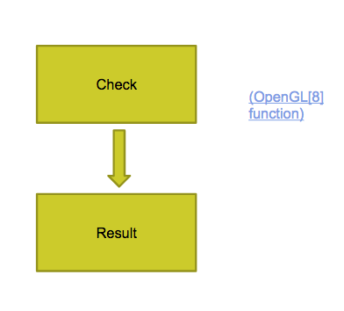

Figure 10

Before we can get the results of a query we will need to check whether the result is available or and we can do that by again using the OpenGL function which return one or zero indicating if the results is ready or not.

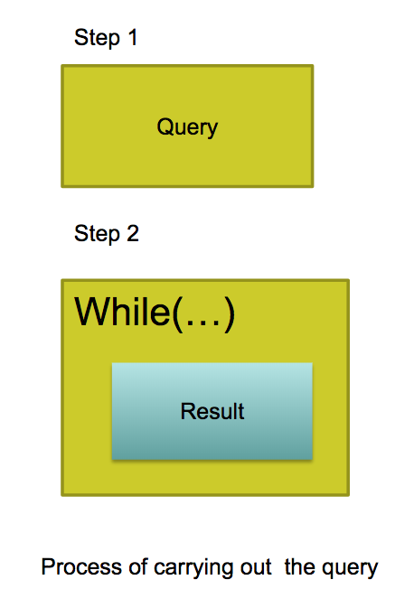

Figure 11

So when carrying out the queries one thing that you could do would be to do the query and then wait for the results in a loop. This is very popular method and practical.

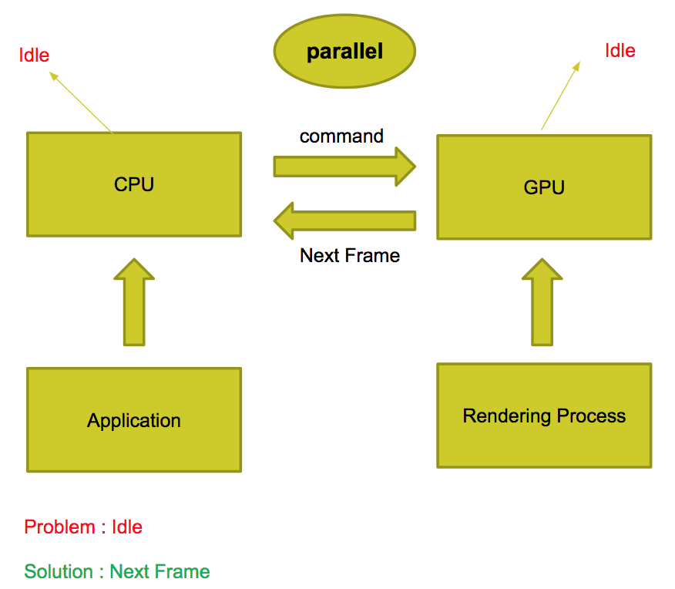

Figure 12

However this isn’t exactly ideal because firstly the CPU will obviously be idle for a while as it waits for the GPU to finish processing all the triangles that have been rendered in this frame so far but also once the GPU does finish all the rendering and it gets the result of the query it will then be idle for a while itself because it has no more tasks queued up and it will have to wait for the application to send the next command from the CPU to the GPU and obviously all this waiting around being idle is wasting valuable processing time and decreases performance. Therefore, my solution is that if we don’t require the result right away then we can avoid stalling the GPU and CPU by simply collecting the results on next frame.

## **Using Occlusion Queries in** **Unity [9]**

Here is a demo by using Unity which is famous graphic engine and has excellent performance on image processing. And so here you do not need to write any code. Instead just clicking some button and drag some widget could implement the Occlusion Queries function that’s pretty cool.

Occlusion Queries is a way of not rendering things that you don’t need to render. Let me give you a quick example. We are going to set up a scene that shows there are a lot of cubes behind a wall.

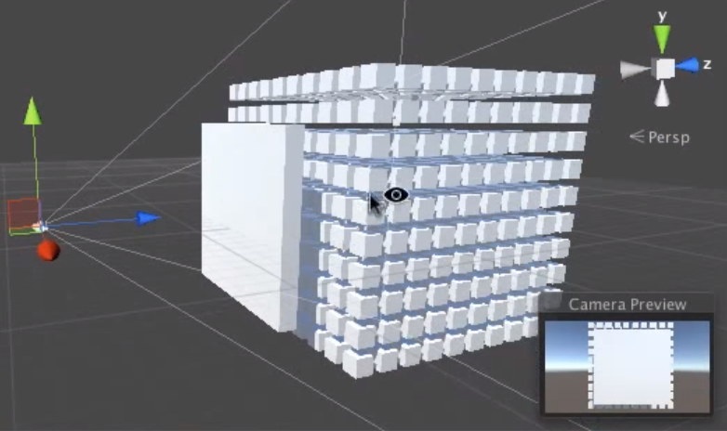

Figure 13

Without Occlusion culling, each cube on the scene will be rendered each frame. The cubes which are occluded by the wall are not disappear automatically. It will lead to the rendering load on the GPU.

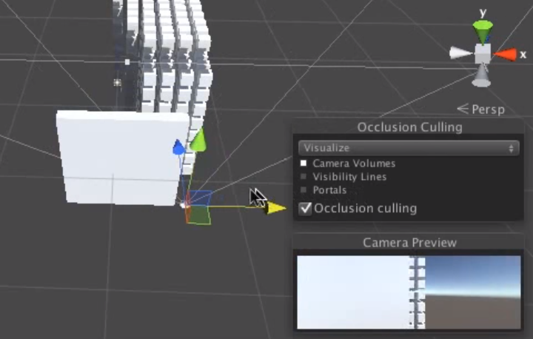

Figure 14

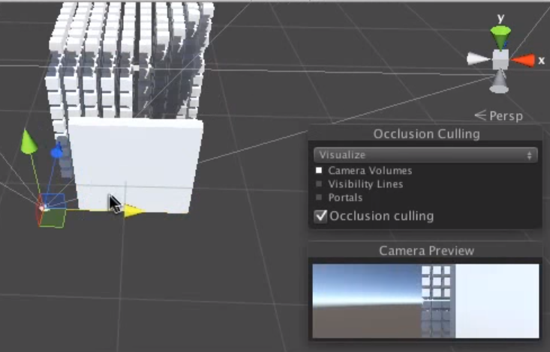

Figure 15

Now, to open the Occlusion culling function, Figure 14 shows that a lot cubes on the left has disappeared when moving the camera to the right. According to Figure 15, a lot of cubes on the right disappeared when moving the camera to the left. That’s cool. And the performance is increasing.

# **DEMO**

Here I wrote a Demo in OpenGL and utilized Occlusion Queries to implement Lens Flare which

often occurs when a point of light is much brighter than other light source such as the sun seeing the Figure 16.



Figure 16

### Lens Flare

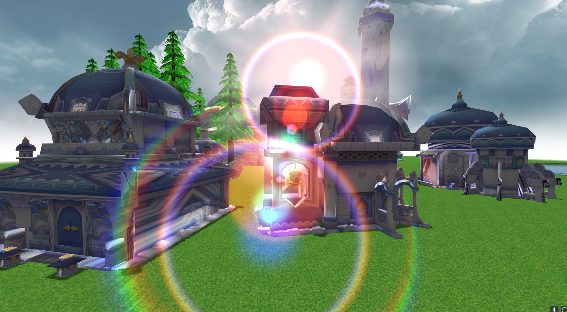

Figure 17

Now, we can see the the lens flare because the house didn’t occlude the sun.

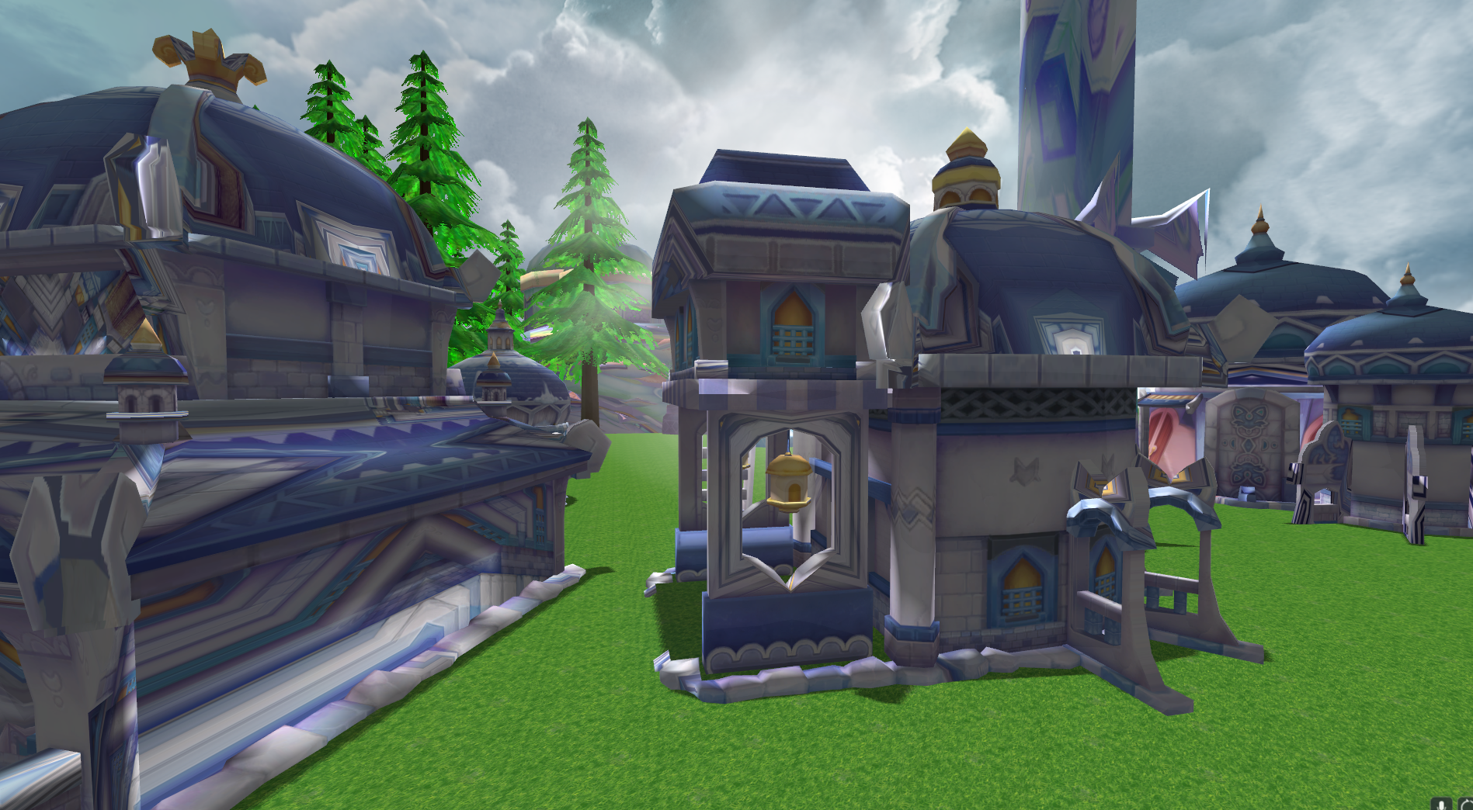

Figure 18

Buf if you walk to the house closely so that the sun can’t be seen the lens flare effect disappeared because the renderer has disable the rendering of the lens flare effect.

### Coding

First, to define the house as Occluders and the Lens Flare as Occludees. Before we draw the sun, we should disable the depth buffer by calling “prepare” function.

**private** **void** prepare(Sun sun, BaseCamera cam) {

GL11.*glDepthMask*(**false**);

OGState.*anti*(**false**);

OGState.*ActiveAlphaBlending*();

sd.begin();

Matrix4f mvpMat = computeMVPMatrix(sun, cam);

sd.mvpMatrix.loadMatrix(mvpMat);

shape.bind(0);

sun.getTexture().bindTex(0);

}

**private** **void** endDrawing() {

GL11.*glDepthMask*(**true**);

shape.unbind(0);

sd.end();

OGState.*DisableBlend*();

}

After drawing the sun, we must enable the depth buffer by calling the “endDrawing” function. To the prepare function, the first thing we need to do is to disable the depth buffer by calling GL11.glDepthMask function then we are going to set two rendering state. One is the OGState.anti that is used to improve the quality of the image and make it more smooth and eliminate the jagged edges of the image. Another is OGState.ActiveAlphaBlending that is used to control the transparency of the object which have been rendered on the screen by adjusting the alpha factor then we are going to use the shader and pass the matrix to shader and bind the vertex and texture.So here the zero means the index of vertex or texture. In other words, we are able to bind more textures and the index is increasing such as one, two, three and so on.

In the endDrawing Funciotn. Firstly, we are going to enable the Depth Buffer and then unbind the vertex and close the shader. Finally, we are going to disable the blend since both prepare and endDrawing fuction are corresponding to one Draw Call. In each frame, you have not only one Draw Call but also thousands of Draw Call. and therefore, if you don’t close the blend rendering state after using it so that will affect other draw calls and lead to error effect on screen that you don’t expect.

**public** **void** draw(Vector2f sunScreenPos, FlareTex[] pflares, **float** pbrightness) {

prepare(pbrightness);

ProcessingOcclusionCulling (sunScreenPos);

OGState.*ActiveAddBlending*();

OGState.*ActiveDepthTest*(**false**);

**for** (FlareTex val : pflares) {

DrawFlare(val);

}

endDrawing();

}

When drawing the Lens Flare, the ProcessingOcclusionCulling function will be called.

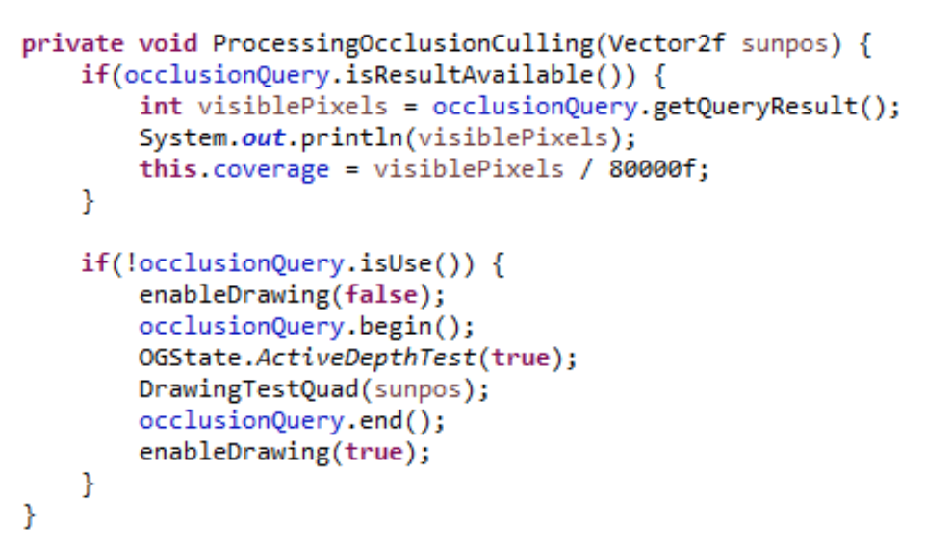

ProcessingOcclusionCulling function is the core of implementing Lens flare effect in the Demo. The first thing we want to do is to check whether the query is already in use so if it isn’t in use then we want to carry out a new occlusion query so that’s going to involve rendering record and before we render the quads we want to start the query and after we render the quads we want to end the query then to get the results as I mentioned we are not going to do this straightaway we are actually going to do this on the next frame so at the start of the next frame we are going to check if the query result is ready and if it is we can get that result and that result is going to be the number of visible pixels of the quad on the screen and for now we are just going to print out that number so that we can see that it’s all working.

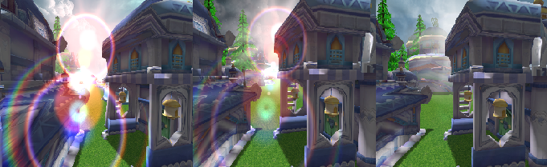

Figure 19

Look at the Figure 19 you are going to see that when the quad isn’t being occluded by anything you get quite a large number and when you put it behind a house or some things so that it can’t be seen at all it should be printing out zero and so now just remember that large number that you get when the quad isn’t hidden at all because that should be the total number of pixels in the quads and we will need that to calculate the percentage of the court that’s covered so in the lens flare, we are now going to calculate the amount of the quads that is visible on the screen and this is going to be a number between 0 and 1 and we are going to calculate the coverage by taking the number of visible samples divided by the total number of samples in the quads and for now we are going to herd code that total number that is 80000 and we are going to multiply the coverage by the brightness of the lens flare effect so that we can then set the brightness of the lens flare effect depending on the percentage of the quad that’s visible so if all the pixels pass the depth test then the lens flare effects will be rendered at normal brightness if only some of the pixels pass the depth test then it will be rendered at partial brightness and when the Sun and the quads are totally hidden no pixels would have passed the depth test and so the coverage will be 0 and therefore the brightness of the lens flare effect will be 0 and you can see the figure 19.

# ***Future work***

As a matter of fact, after understanding the whole theory of Occlusion Query. we can use DirextX which has an excellent performance in Image processing to implement it.

##### **Conclusion**

We had illustrated that the theory of occlusion culling to how to increase rendering performance and utilized this technology to implement a lens flare effect in a demo by using OpenGL that’s pretty cool. In the future work, applying occlusion culling on DirectX [10] platform that would be a challenge.

##### ***KNOWLEDGMENT***

Many thanks to Dr.Yanjun Zhao. The subject of this thesis was challenging to me. She made this experience really valuable for me. Thank you so much!

##### ***References***

[1] Fast-extraction-viewing-frustum-planes-from-world-view-projection-matrix

[2] Occlusion Culling with Statistically Optimized Occlusion Queries

[3] High-performance, Low-Overhead Rendering with OpenGL - Nvidia

[4] Homomorphic Factorization of BRDFs for High-Performance Rendering

[5] Depth In-depth - Semantic Scholar

[6] What Every CUDA Programmer Should Know About OpenGL - Nvidia

[7] Rendering

[8] An Interactive Introduction to OpenGL Programming

[9] New Unity products

[10] Learn Network Inspire

[11] AIREY, J. M., ROHLF, J. H., ANDBROOKS,JR., F. P. Towards Image Realism with Interactive Update R.Ates in Complex Virtual Building Environments. ACM Siggmph Special Issue on 1990 Symposium on Interactive 3D Gmphics 24, 2 (1990), 41-50.

[12] AKELEY, K. RealityEngine Graphics. SIGGRAPH ’93 Conference Proceedings (1993), 109-116.

[13] BENTLEY, J. Multidimensional binary search trees used for associative searching. Communications of the ACM 18 (1975), 50%517.

[14] CATMULL, E. E. A Subdiwsion Algorathm for Computer Display of Curved Surfaces. PhD thesis, University of Utah, Dec. 1974.

[15] COORG, S., AND TELLER, S. Temporally Coherent Conservative Visibility. In Proc. 12th Annual ACM Srjmposium on Computational Geometry (1996), pp. 78–87.

[16] FUNKHOUSER, T., SEQUIN, C., AND TELLER, S. Management of Large Amounts of Data in Interactive Building Walkt hroughs. In 1+-oc. 1992 Workshop on Interactive 3D Gmphics (1992), pp. 11–20.

[17] GARLICK, B., BAUM, D. R., AND WJNGET, J. M. Interactive Viewing of Large Geometric Databases Using Multiprocessor Graphics Workstations. Siggraph ’90 Course Notes (Parallel Algon”thms and Architectures for 3D Image Generation) (1990).

[18] GREENE, N., AND KASS, M. Error-Bounded Antialiaaed Rendering of Complex Environments. In SIGGRA PH ’94 Conference Proceedings (1994), pp. 59–66.

[19] GREENE, N., KASS, M., AND MILLER, G. Hierarchical Z-BufFer Visibility. In SIGGRAPH ’93 Conference Proceedings (1993), pp. 231-240.

[20] LUEBKE, D., AND GEORGES, C. Portals and Mirrors: Simple, Fast Evaluation of Potentially Visible Sets. In Proc. 1995 Symposium on Interactive 3D Graphics (1995), pp. 105-106.

[21] MACIEL, P. W. C., AND SHIRLEY, P. Visual Navigation of Large Environments Using Textured Clusters. In Proc. 1995 Symposium on Zntemctive 3D Graphics (1995), pp. 95-102.

[22] NAYLOR, B. F. Partitioning !llee Image Representation and Generation from 3D geometric models. In Proc. Graphics Interface ’92 (1992), pp. 201-211.

[23] SHADE, J., LMCHINSKI, D., SALESIN, D., DEROSE, T., AND SNYDER, J. Hierarchical Image Caching for Accelerated Walkthroughs of Complex Environments. In SIG GRAPH ’96 Conference Proceedings (1996), pp. 75-82.

[24] SUTHERLAND, 1. E., SPROULL, R. F., AND SCHUMACHER,R. A. A Characterization of Ten Hidden-Surface Algorithms. Computing Surveys 6, 1 (1974), 1-55.

[25] TELLER, S., AND SEQUIN,C. H. Visibility Preprocessing for Interactive Walkthroughs. SIGGRAPH ’91 Conference Proceedings (1991), 61- 69.

[26] XIONG, R. A Stratified Rendering Algorithm for Virtual Walkthroughs of Large Environments. Masters Thesis, EECS Department, MIT, May 1996.